MED D - Specialized Member Services Team (SMST) – PeopleSafe Disenrollment Reasons Guide

General Information

Reference Chart

Related Documents

Description: The document assists the Specialized Member Services Team (SMST) with locating the correct process or work instructions when a beneficiary has been disenrolled.

General Information
When researching the reason why a beneficiary has been disenrolled, the CCR will refer to the PeopleSafe - Medicare D Inquiry - Disenrollment Reason.

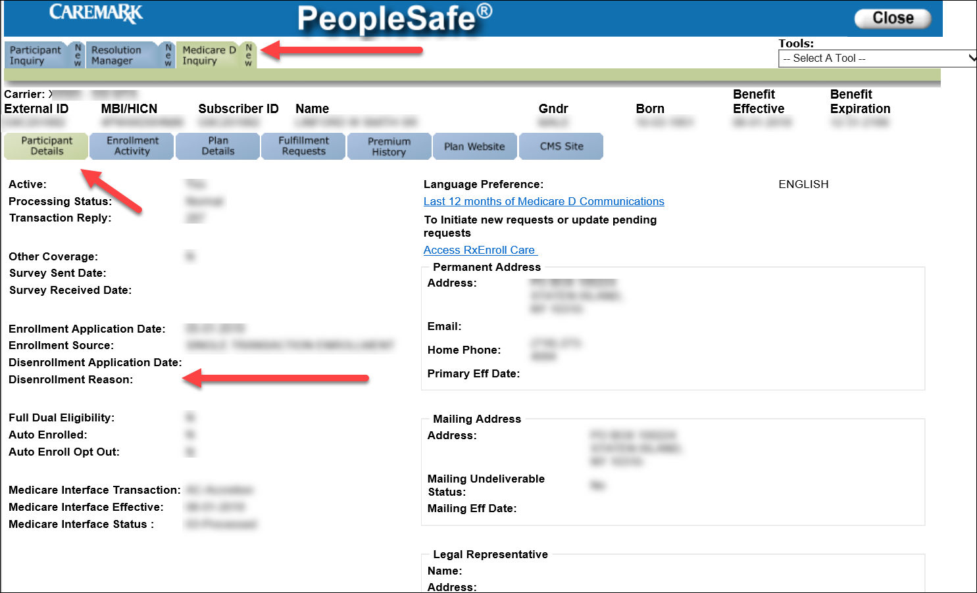

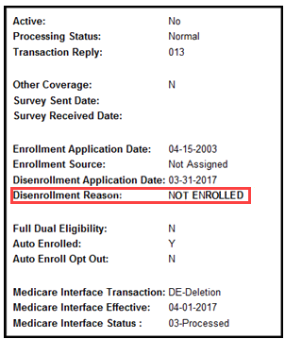

Note: The CCR should also reference disenrollment letters in the Last 12 months of Medicare D Communications and all previous call notes in the Participant Inquiry tab - View Comments and the Medicare D Inquiry tab - Comments section.

Top of the Document

Reference Chart

The CCR will utilize the chart below to determine the correct work instruction by the Disenrollment Reason.
Disenrollment Reason | Description | Work Instruction
- OUT OF AREA DISENROLLMENT | Beneficiary has confirmed a change in residence outside their current service area/region and must be disenrolled. This includes moving out of the country. | MED D - Address Changes and Out of Area (OOA)  MED D - RxEnroll Care Downtime Procedures - Address Changes and Out of Area (OOA)
- INCARCERATED | Beneficiary is confirmed to be in the custody of a penal authority and confined to a correctional facility, such as a jail or prison, or a mental health institution as a result of a criminal offense.  Such individuals reside outside of the service area for the purposes of Part D plan eligibility, even if the correctional facility is located within the plan’s service area.. | MED D - Address Changes and Out of Area (OOA)  MED D - RxEnroll Care Downtime Procedures - Address Changes and Out of Area (OOA)  MED D – SilverScript and Blue MedicareRx (NEJE) – Resolving Eligibility Issues for Incarcerated or Not Lawfully Present Beneficiaries
- UNLAWFULLY PRESENT | Beneficiary is considered not lawfully present (not a US citizen). An individual who is not lawfully present in the United States is not eligible for any federal public benefit, including payment of Medicare benefits. | MED D – SilverScript and Blue MedicareRx (NEJE) – Resolving Eligibility Issues for Incarcerated or Not Lawfully Present Beneficiaries
- LOSS PART D ELIGIBILITY | Beneficiary has lost entitlement/eligibility for Medicare benefits. This includes the loss of Part A, Part B, and or Part D. | MED D - Specialized Member Services Team (SMST) - Mistaken Disenrollment
- MEMB DECEASED | Beneficiary has been reported deceased by the Social Security Administration (SSA) and Medicare as notified the plan. | MED D - Deceased Beneficiary  Note: If the caller (or beneficiary) states that the beneficiary is not deceased, refer to: MED D - Specialized Member Services Team (SMST) - Mistaken Disenrollment
- IRMAA DISENROLLMENT | Beneficiary failed to pay Income Related Monthly Adjustment Amount (IRMAA) payments with their Part D premium. | MED D SilverScript - Process for Good Cause Determinations for Nonpay of IRMAA
- NON NEJE INV TERM  OR  INVOLUNT DISENROLL NO PAY PREM | Beneficiary failed to pay premiums timely and was disenrolled through the dunning process. | Aetna MED D SilverScript - Premium Billing Dunning and Disputes Process
- DISENROLL – NEW MCO | Beneficiary was or will be disenrolled at a future date due to enrollment in another Part D plan. | MED D - Specialized Member Services Team (SMST) - Disenrollment due to Enrollment in a Different Prescription Drug Plan
- DISENROLL - NEW MMP | Beneficiary will be disenrolled due to CMS enrolling the beneficiary into a Medicare Advantage: Medicare-Medicaid Plan (MMP). | MED D - CMS Passive Enrollment in MMP - Required Voluntary Disenrollment from the PDP, Opt-Out and Disenrollment from the MMP
- NOT ENROLLED   | The beneficiary is disenrolled from the Part D plan.  Note: This reason is associated with several different processes but is most often seen once a member has completed the Voluntary Disenrollment process. | To review the status of a disenrollment request:  - MED D - Specialized Member Services Team (SMST) - Voluntary Disenrollment  If the beneficiary is disenrolled and wishes to enroll, advise the beneficiary that they must complete a new enrollment.  Warm Transfer to:  1-844-985-0085  Internal Use Only  Enter Caller’s Zip Code when prompted.  Note: Phone number to provide to the beneficiary if requested is 1-833-606-0372. Advise the caller not to select Option 1 as this will return the caller to SilverScript Customer Care. State there will be two selections to make and provide the appropriate Options to select for each call type below:  - Current enrolled beneficiary: Select Option 2 and then Option 1  - Prospective (non-beneficiary): Select Option 2 and then Option 2
- INVOL EGWP DSNRLL - ADV NTC  Beneficiary will be disenrolled from current EGWP plan. |  | - Review the “Last 12 months of Medicare Communications” for any letters sent to the beneficiary.  - Review the applicable CIF for additional information.

Top of the Document

Related Documents
- Grievance Standard Verbiage (for use in Discussion with Beneficiary) section in MED D - Grievances Index
- MED D - SHIP Counselor Calls for CVS Caremark Part D Plans
- MED D - Appointed Representative Form (AOR) or Power of Attorney (POA)
- MED D - SilverScript and Blue MedicareRx (NEJE) - Enrollment Related RM Tasks
- MED D - Election Periods for Enrollment and Disenrollment (AEP, IEP, SEP)
- MED D - CMS Passive Enrollment in MMP - Required Voluntary Disenrollment from the PDP, Opt-Out and Disenrollment from the MMP

Parent SOP:
- MEDS-0041: Medicare Part D Voluntary Disenrollment, CVS Caremark Part D Services, L.L.C., Policy and Procedure
- MEDS-0006: Medicare Part D - Cancellation of Enrollment and Disenrollment Policy and Procedure, CVS Caremark Part D Services, L.L.C.
- CALL-0048: Medicare Part D - Customer Care Call Center Requirements, CVS Caremark Part D Services, L.L.C.
Abbreviations/Definitions:
- Abbreviations / Definitions

Top of the Document

Not To Be Reproduced Or Disclosed to Others Without Prior Written Approval
ELECTRONIC DATA = OFFICIAL VERSION – PAPER COPY = INFORMATIONAL ONLY

